**Graphs (in terms of Delta L metres vs d metres):**

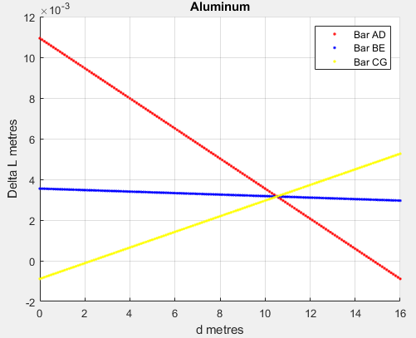

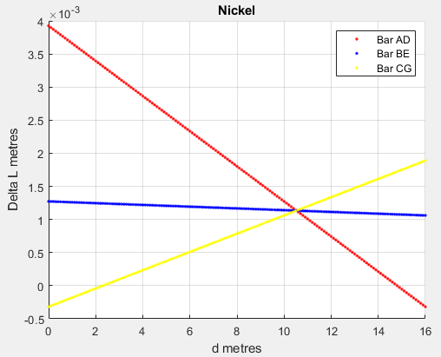

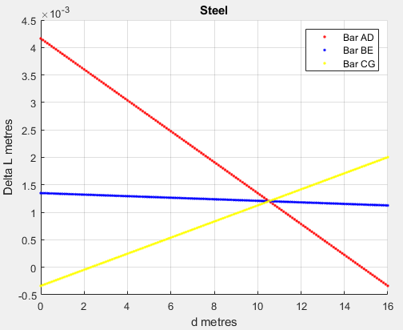

**Graphs (In terms of Elongation % vs d metres):**

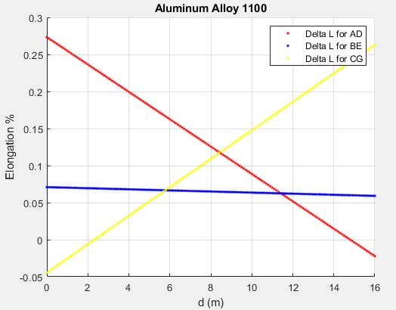

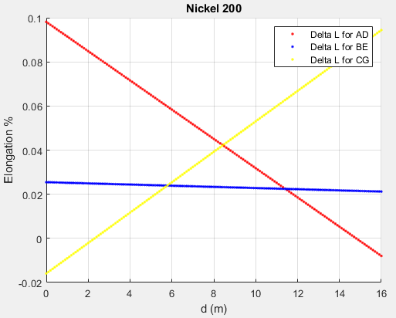

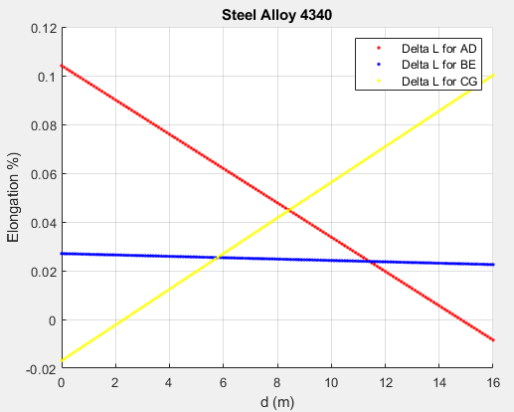

**Code:**

P=90000;

E_Al=75000000000;

E_Ni=209000000000;

E_Steel=197000000000;

A=0.0004;

L_AD=4;

L_BE=5;

L_CG=2;

delta_L_AD=0;

delta_L_BE=0;

delta_L_CG=0;

%ALUMINUM

for d= 0:0.1:16;

matrix_A=[ 1 1 1;

0 10 16;

(24/(E_Al*A)) (-80/(E_Al*A)) (20/(E_Al*A))];

matrix_B=[P; d*P; 0];

force_matrix=matrix_A\matrix_B;

delta_L_AD=(force_matrix(1)*L_AD)/(E_Al*A);

delta_L_BE=(force_matrix(2)*L_BE)/(E_Al*A);

delta_L_CG=(force_matrix(3)*L_CG)/(E_Al*A);

figure(1);

hold on;

grid on;

plot(d, delta_L_AD, 'r.');

plot(d, delta_L_BE, 'b.');

plot(d, delta_L_CG, 'y.');

title('Aluminum');

xlabel('d metres');

ylabel('Delta L metres');

legend('Bar AD', 'Bar BE', 'Bar CG');

end

%NICKEL

for d= 0:0.1:16;

matrix_A=[ 1 1 1;

0 10 16;

(24/(E_Ni*A)) (-80/(E_Ni*A)) (20/(E_Ni*A))];

matrix_B=[P; d*P; 0];

force_matrix=matrix_A\matrix_B;

delta_L_AD=(force_matrix(1)*L_AD)/(E_Ni*A);

delta_L_BE=(force_matrix(2)*L_BE)/(E_Ni*A);

delta_L_CG=(force_matrix(3)*L_CG)/(E_Ni*A);

figure(2);

hold on;

grid on;

plot(d, delta_L_AD, 'r.');

plot(d, delta_L_BE, 'b.');

plot(d, delta_L_CG, 'y.');

title('Nickel');

xlabel('d metres');

ylabel('Delta L metres');

legend('Bar AD', 'Bar BE', 'Bar CG');

end

%STEEL

for d= 0:0.1:16;

matrix_A=[ 1 1 1;

0 10 16;

(24/(E_Steel*A)) (-80/(E_Steel*A)) (20/(E_Steel*A))];

matrix_B=[P; d*P; 0];

force_matrix=matrix_A\matrix_B;

delta_L_AD=(force_matrix(1)*L_AD)/(E_Steel*A);

delta_L_BE=(force_matrix(2)*L_BE)/(E_Steel*A);

delta_L_CG=(force_matrix(3)*L_CG)/(E_Steel*A);

figure(3);

hold on;

grid on;

plot(d, delta_L_AD, 'r.');

plot(d, delta_L_BE, 'b.');

plot(d, delta_L_CG, 'y.');

title('Steel');

xlabel('d metres');

ylabel('Delta L metres');

legend('Bar AD', 'Bar BE', 'Bar CG');

end

**Questions:**

1. Knowing that none of the bars should elongate by more than 0.1% of their original length, the three graphs tell us that **Nickel** (the most dense metal) can be used for all of the vertical bars to ensure that P = 90 kN.
2. Looking at the graph of the nickel metal, we see that the AD, BE and CG force lines all intersect when the x-axis or length of d is equal to **10.5 metres** to the right of A on the horizontal.

**Long Answers:**

1. We need to determine which material the system should be made of to sustain the force ‘P’ and not have the vertical bars elongate by 0.1% of their individual original lengths. For the second question, we are being asked to determine the distance the weight of the horizontal bar should be at in perspective to point A, to make sure that the bar remains horizontal. As distance increases, I think that the bars that ‘P’ is approaching will have increasing elongations and the bars that ‘P’ is moving away from will face smaller and smaller elongation.
2. I think it would be useful to construct a matrix with the equations given. The delta L equation should be replaced with a Forces equation in order to simplify it further. We should test multiple values of “d” as it increases from 0-16 to determine which material would not elongate more than 0.1% for all values of d. To calculate every value of “d” would be cumbersome, so we could make use of the for loop and increase d by 0.1 to have a reasonable number of test values.
3. The code for the graphs is above. Since the elongation percentages for Aluminum and Steel are higher than 0.1% for certain values of d, the system ca not be made of these materials. Only Nickel fits the description of having elongation for all the bars being less than 0.1%.
4. Looking back, I think I have solved the problem. My answers make sense, corresponding to the graphs. We had to consider what variables to have in our matrix so that the variables are constant. For example, we had to rewrite ‘ΔL’ in terms of ‘F’ so that the system is consistent.